Defend Against Memory Poisoning in Amazon Bedrock AgentCore with Multi-Layer Write Validation

Summary

Implement a real-time memory write validation pipeline for AI agents on Amazon Bedrock AgentCore that detects and neutralizes memory poisoning attacks. The pipeline uses a Gateway interceptor Lambda to score every memory write against 4 detection signals i.e., semantic drift, instruction-pattern detection, namespace boundary enforcement, and write-rate anomaly and applies a graduated response (allow, quarantine, or deny) before content reaches persistent memory.

Problem

AI agents on Amazon Bedrock AgentCore use persistent memory (AgentCore Memory) for cross-session context, user preferences, and shared domain knowledge. This memory is retrieved and injected into the agent's context automatically that means anything stored in memory directly influences the agent's future behavior.

Memory poisoning exploits this trust: an attacker embeds malicious instructions in content that gets written to long-term memory. Unlike ephemeral prompt injection (which resets each session), poisoned memories persist indefinitely and can:

- Corrupt agent behavior across ALL future sessions
- Spread to other agents sharing the same memory namespace
- Execute days or weeks later, triggered by unrelated interactions
- Survive undetected because the agent appears to function normally

Current gaps

- AgentCore Policy (Cedar) controls WHO can access memory, but not WHAT gets written
- AgentCore Guardrails filter model outputs but don't inspect memory write operations
- AgentCore Gateway provides the interception point but no built-in memory validation

The attack surface is amplified by AgentCore Memory's shared namespace feature — where a single poisoned write in a shared namespace can influence every agent that reads from it.

When to use this pattern

- You have agents on AgentCore Runtime that use persistent memory (short-term or long-term)
- Your agents share memory namespaces across sessions or across agents
- You handle sensitive data where corrupted agent behavior could cause real harm (financial, healthcare, PII)
- You need defense-in-depth beyond Cedar policies and Guardrails

When NOT to use this pattern

- Agents with no persistent memory (stateless, single-turn only)
- Development/testing environments where memory writes are not production-sensitive
- Extremely latency-sensitive paths where even 26ms additional latency is unacceptable

Prerequisites

- Amazon Bedrock AgentCore Runtime with Memory enabled
- AgentCore Gateway configured (for interceptor attachment)
- AgentCore Policy (Cedar) configured
- AWS Lambda, Amazon DynamoDB, Amazon SNS
- Amazon Bedrock model access (Titan Embeddings v2)
- AWS CDK v2 for deployment

Architecture

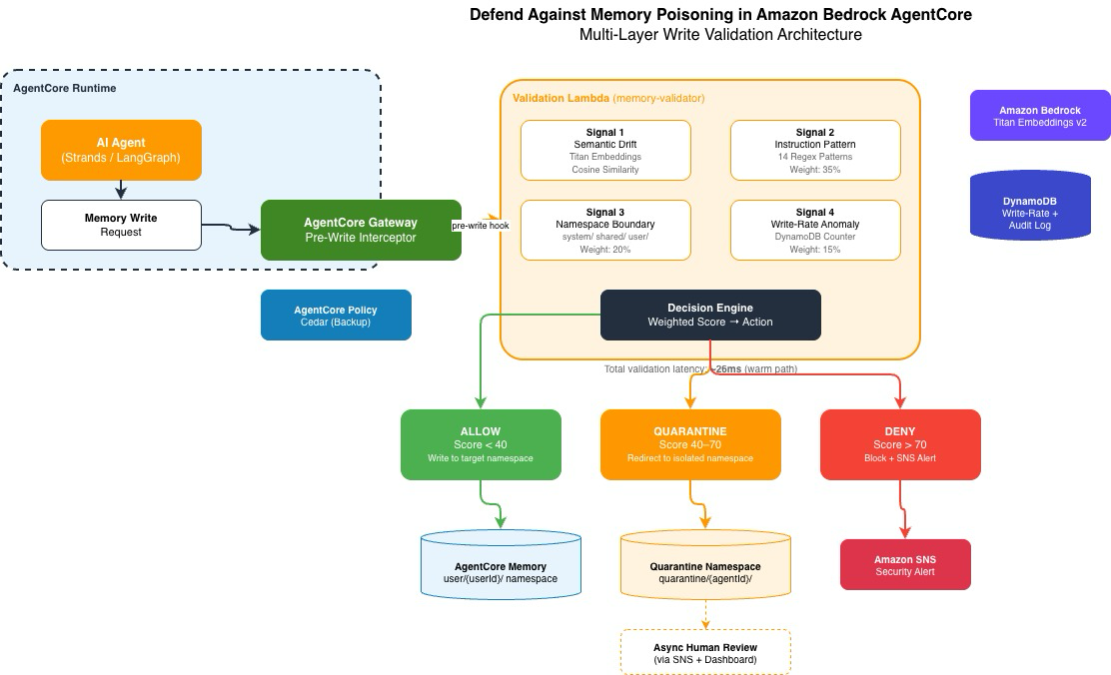
Detection Signals

Signal | Weight | What It Detects | Technique
Semantic Drift | 30% | Write content unrelated to session context | Titan Embeddings cosine similarity
Instruction Pattern | 35% | Embedded system-prompt-like commands | Regex pattern matching (14 patterns)
Namespace Boundary | 20% | Writes targeting protected namespaces | Namespace prefix matching + session context
Write-Rate Anomaly | 15% | Burst writes indicating automation | DynamoDB counter vs. historical baseline

Namespace Trust Hierarchy

system/ No runtime writes (deployment-only)
user/{userId}/ Standard validation (4-signal, threshold 40/70)
shared/ Enhanced validation (stricter threshold: 30/60)
quarantine/ Validator-only write access; agents cannot read

Implementation

Step 1: Deploy Infrastructure

The CDK stack (see `infrastructure/cdk-stack.ts`) provisions:

- Validation Lambda with provisioned concurrency
- DynamoDB tables (write-rate tracking + audit log)
- SNS topic for alerts

bash
cd infrastructure && cdk deploy

Step 2: Configure Gateway Interceptor

Attach the deployed Lambda as a pre-write interceptor on AgentCore Gateway:

```typescript
// AgentCore Gateway configuration
{
"interceptors": {
"memory": {
"preWrite": {
"lambdaArn": "<ValidatorFunctionArn from CDK output>",
"timeoutMs": 5000,
"failurePolicy": "ALLOW" // Fail-open for availability
}
}
}
}
```

Step 3: Apply Cedar Policies

Deploy the Cedar policies (see `policies/namespace-isolation.cedar`) to AgentCore Policy. These enforce namespace-level access control as a secondary defense layer.

Step 4: Configure Alerts

Subscribe your security team's email/Slack/PagerDuty to the SNS topic for QUARANTINE and DENY notifications.

Metric | Value
Warm-path latency | ~26ms
Cold-start latency | ~230ms (mitigated with provisioned concurrency)
DynamoDB read | ~5ms (sub-3ms with DAX)
Embedding generation | ~12ms (Titan Embed v2, 256 dimensions)
Memory overhead | 512MB Lambda

Cost Considerations

- Lambda: ~$0.0000067 per invocation (512MB, 100ms)
- DynamoDB: On-demand pricing, minimal reads/writes per memory operation
- Titan Embeddings: $0.00002 per 1K tokens (2 invocations per validation)
- SNS: Standard messaging rates (only on QUARANTINE/DENY)

For an agent fleet generating 10,000 memory writes/day: **~$2.50/day** total validation cost.

Limitations

- Embedding-based detection is not foolproof: Sophisticated attacks that maintain topical relevance while embedding subtle instructions may evade semantic drift detection
- Regex patterns require updates: New injection techniques may not match existing patterns; periodic pattern updates recommended
- Cold starts: First invocation after idle period adds ~230ms; mitigated with provisioned concurrency but adds cost
- Fail-open design: If the Lambda errors out, writes proceed unvalidated (availability over security trade-off — configurable)

Related Resources

- [AWS Docs: AgentCore Memory Best Practices](https://docs.aws.amazon.com/bedrock-agentcore/latest/devguide/best-practices.html)
- [AWS Blog: Organizing Agents' Memory at Scale — Namespace Design Patterns](https://aws.amazon.com/blogs/machine-learning/organizing-agents-memory-at-scale-namespace-design-patterns-in-agentcore-memory/)
- [AWS Blog: Secure AI Agents with Policy and Lambda Interceptors in AgentCore Gateway](https://aws.amazon.com/blogs/machine-learning/secure-ai-agents-with-policy-and-lambda-interceptors-in-amazon-bedrock-agentcore-gateway/)
- [Palo Alto Unit 42: When AI Remembers Too Much](https://unit42.paloaltonetworks.com/indirect-prompt-injection-poisons-ai-longterm-memory/)
- [OWASP Top 10 for Agentic Applications 2026](https://owasp.org/www-project-top-10-for-large-language-model-applications/)

